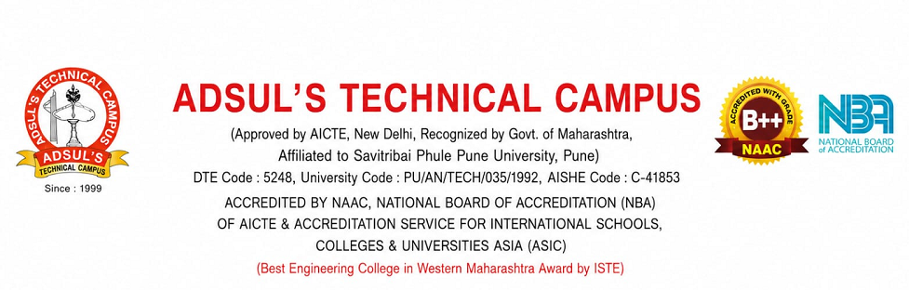

Mr. Ravindra Arun Bhagwat E-Mail id:bhagwatravi70@rediffmail.com
Mobile No: 9021697774
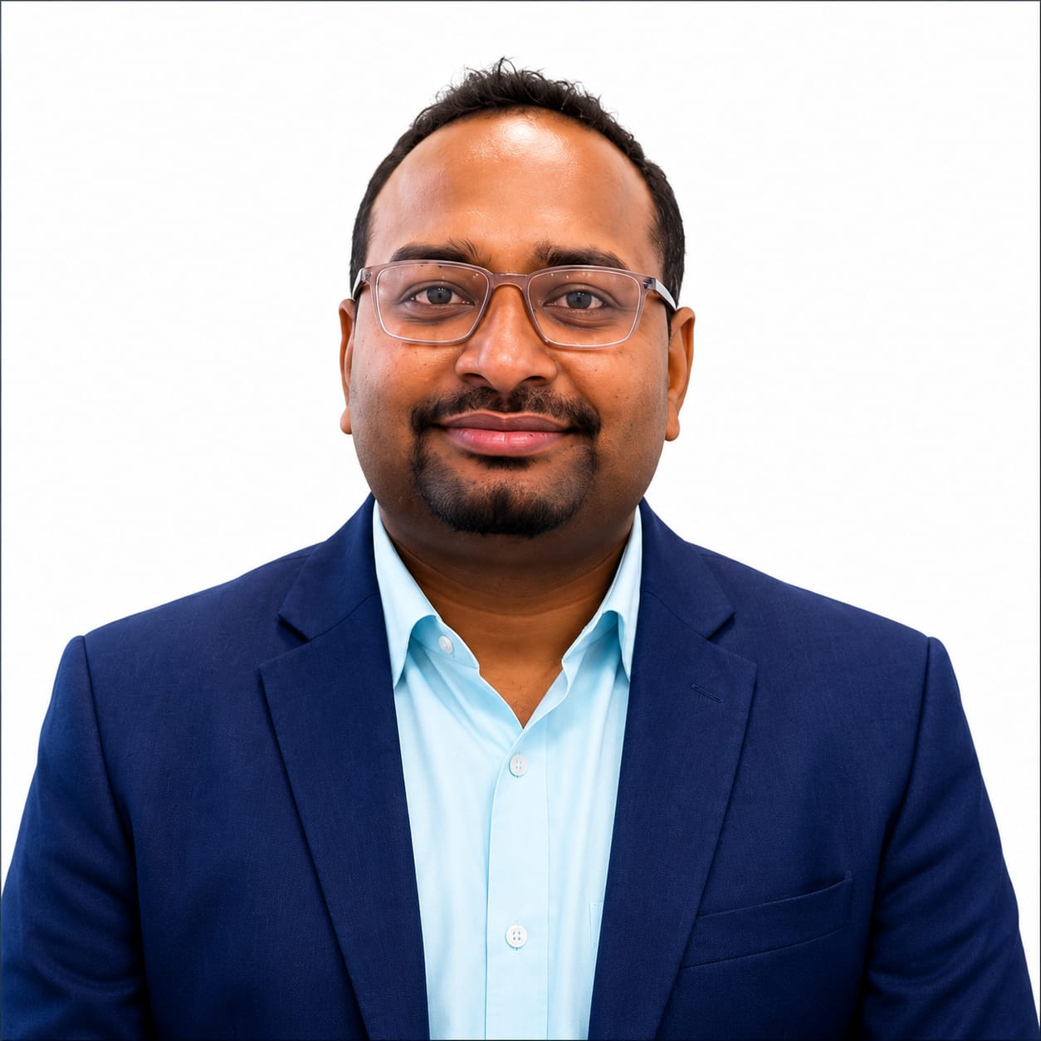

Objective
To secure a challenging position in a reputed organization where I can leverage my expertise in information technology, academic administration, leadership, and teaching to contribute to organizational growth and excellence. I aim to utilize my technical knowledge, management skills, and commitment to continuous learning to drive innovation, enhance operational efficiency, and achieve organizational objectives while fostering professional and personal development.

Personal Details
Gender: Male
Marital Status: Unmarried
D.O.B:17\09\1996 Age: 29
Language Proficiency: English, Hindi & Marathi Address :At Post Bhagwat Erandgaon Tal Shevgaon Dist Ahilyanagar Pin Code:- 414502
Specialization: MBA – Finance

Academic Qualification | Inst/University/ Board | Year of Passing | SGPA/PERCENTAGE
MBA | Savitribai Phule Pune | 2020 | 65.07
Graduation: BCA | Tilak Maharashtra Vidyapeeth Pune | 2018 | 63.61
HSC | Maharashtra Board | 2015 | 69.07
SSC | Maharashtra Board | 2013 | 64.00

My Strength
- Leadership and team management •
- Strong troubleshooting and problem-solving skills
- • Excellent communication and presentation abilities
- • Decision-making and organizational skills

Skills
- Adapting to Changing Circumstances
- Decision Making
- Determination
- Leadership

Academic / Certification/ Professional Achievements
- Demonstrated leadership as HOD, enhancing student engagement and departmental performance. Successfully managed IT infrastructure across multiple locations.
- Delivered impactful presentations and training sessions for staff and students.
- Recognized for effective team collaboration and achieving project goals.

Extra Curricular Activities
- Participated in various Course in IT
- Participated in college level Kabaddi Winner.
Research papers:- 1. Chat GPT And AI Book: - NA

Book Chapters: - NA Patent / Copy Write :- NA

Technical Skills
- Have Good knowledge of IT System.
- Operating Systems: Windows (95/98/XP/2000/Vista/7/8/10), Mac OS Servers: Windows Server(2003/2008/2010),SQL Server, VMware- Tools: Adobe
- • Photoshop, CorelDraw, AutoCAD, Tally ERP
- • Networking: LAN/WAN support, Active Directory, Exchange Server Programming HTML ,Java,

Advanced Java, Linux basics •
- Other Skills: Online examination systems, website maintenance, and software installation.

DECLARATION
I hereby declare that the details furnished above by me are true to the best of my knowledge and I put forward my candidature for placements.

Place: Ahilyanagar Signature:- 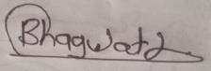
Date :- 28-07-2026 Name:- Prof- Bhagwat R.A

