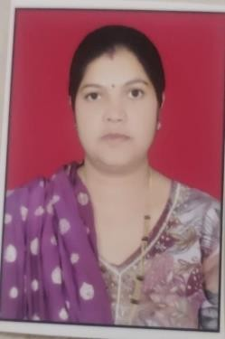
RESUME
Name: Deepmala Lalit Karosiya
Add: Samta Colony no 2 near Bigwell Khamgaon Dist-Buldhana Pincode-444303
Email: deepmalakarosiya1412@gmail.com
Academic Profile:
Course | Discipline | College/School | University/  Board | Passing Year
Post-Graduation | MBA | Sabarmati University | Sabarmati University | 2023
Graduation | B.COM | MG College | Pune University | 2005
HSC | COMM | MG college | Nasik | 2002
SSC | English | S.G.G.S  Manmad | Nasik | 2000
MS-CIT |  |  | MKCL | 2005
Tally ERP 9 |  |  | MKCL | 2021

Other skills:
- Typing 30 wpm English Job skills:
- Ability to work in team
- Committed to work in project deadlines & schedules
- Organized & well-structured at work Soft skills :
- Ability to grasp & learn new technology quickly and accurately

- Very enthusiastic & well motivated with a positive attitude
- Flexibility & Adaptability Work Experience:
- Fresher Personal Details:
- Languages : Hindi , English & Marathi
- Marital status: Married
Declaration:
I hereby declare that all the information & facts given are true and best of my knowledge.
Place: Ahmednagar

Yours Faithfully
Deepmala Karosiya

